Experiment No. 2

Title: Design and implement web application in a short sprint using scrum framework. Problem Description: Students are expected to develop a 2-to-3-page web/mobile application by forming the team of 6 members.
The roles are to be decide by team members:
➢ Product owner- course instructor/ 1 student from team. ➢ Scrum master- manages the process, conduct meetings ➢ Development team- Build and deliver product.
The Scrum process has to be managed using the agile tool – jira /Trello. Free versions.

Aim:
To develop a 2–3 page web/mobile application by applying Scrum framework and managing the sprint using an agile tool.

Tools Required:
- Agile Tool: Jira (Free version)
- Programming Tools: VS Code / Android Studio / Any IDE
- GitHub (optional for version control)
- Browser

Observation / Procedure
Step 1: Team Formation 1. Form a team of 6 members.
2. Assign roles:
    - Product Owner
    - Scrum Master
    - Development Team (4 members)

Step 2: Project Selection
- Select a simple 2–3 page application. Examples: (Your project details)
    - Student Attendance System
    - To-Do List Application
    - Online Quiz System ❖ Mini E-Commerce Page
- Clearly define:
    - Problem statement
    - Objective of application
    - Target users

Step 3: Create Agile Workspace
- Create an account in Jira.
- Create a new project board.
- Choose Scrum template.
Steps:
1. Set up the space. Name the space and then click get started
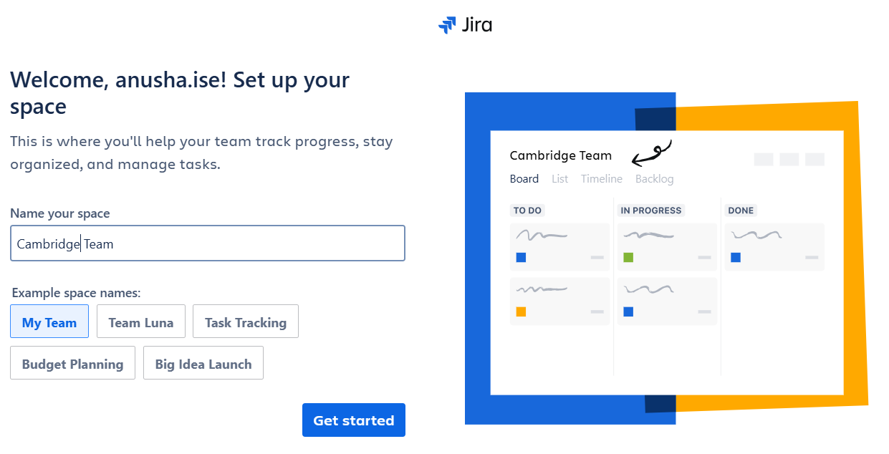
2. Select the tasks that need to be done and click next.
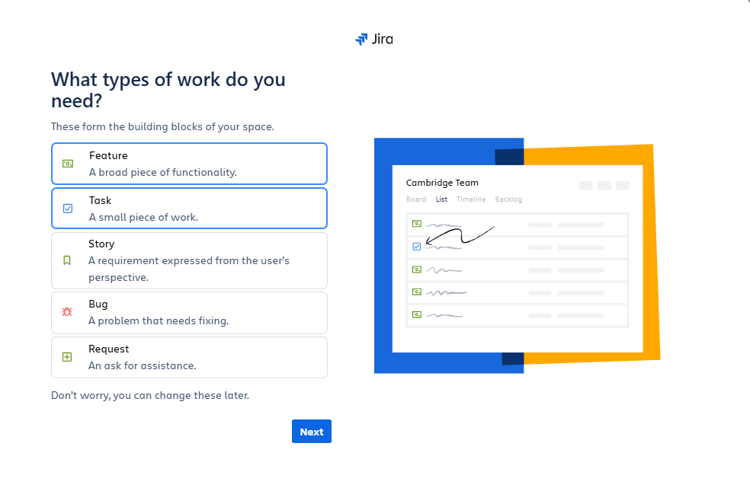
3. Track the work and click next.
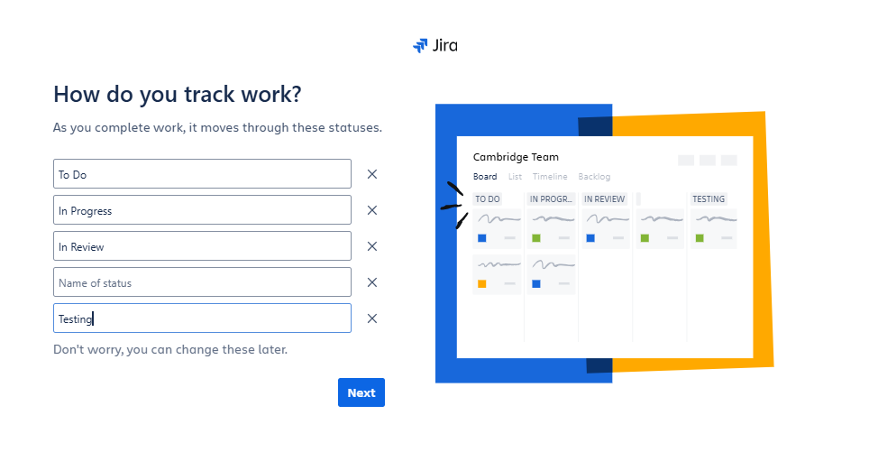
4. Click on go to Jira and create a project.
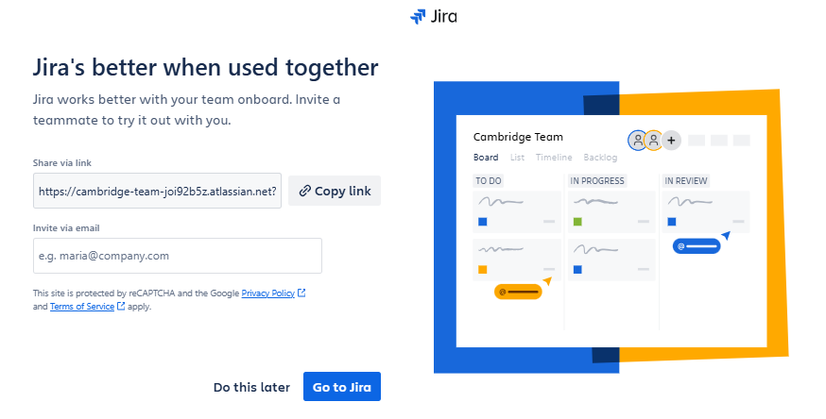
5. Select teams from options for adding the members into the team.
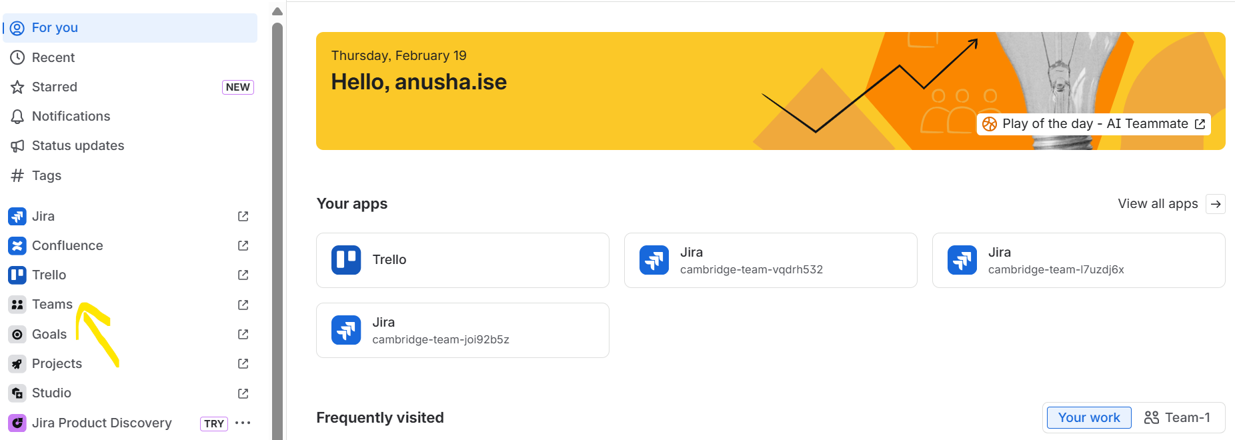
6. Add members to the team
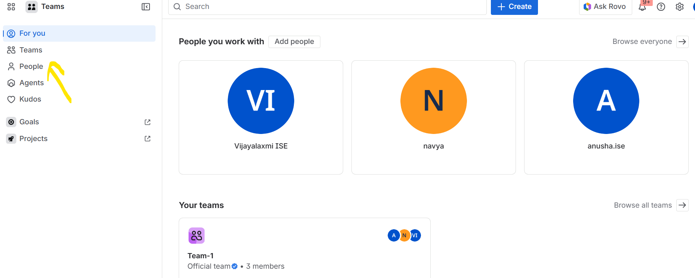
7. Add members to the team by specifying the mail id of the members and click add.
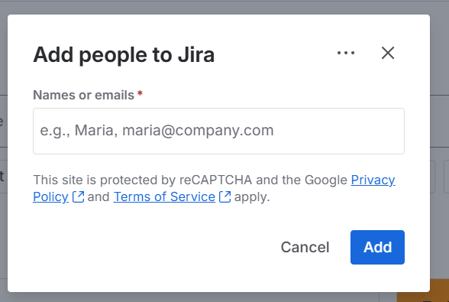
8. Go to Teams and create a team by giving name to the team and click create
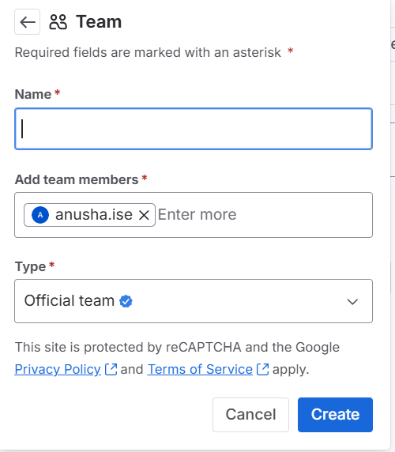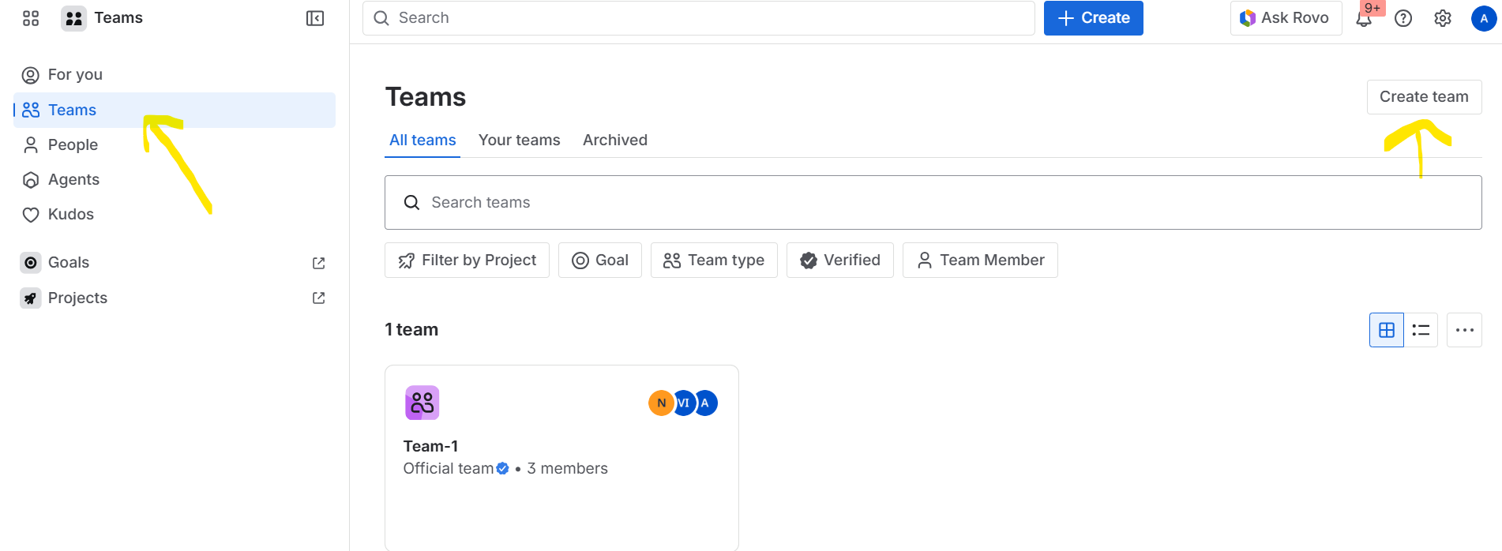

- Create columns: ❖ Backlog
    - To Do
    - In Progress
    - Testing
    - Done

Step 4: Create Product Backlog
1. Product Owner lists features as User Stories. Format:
As a user, I want to ______ so that ______.
Example:
      - As a user, I want to login so that I can access my dashboard.
      - As a user, I want to add tasks so that I can manage my work.
2. Add minimum 8–10 user stories.

Step 5: Sprint Planning
- Decide sprint duration (3–5 days).
- Select user stories for Sprint 1.
- Break each story into tasks.
- Assign tasks to team members.
- Estimate effort (story points or simple priority).

Step 6: Conduct Daily Scrum
- Conduct 10-minute daily meeting.
- Each member answers:
  - What did I complete?
  - What will I do next? ❖ Any obstacles?
- Scrum Master updates board status.

Step 7: Development Phase 1. Developers implement features.
2. Move task cards:
❖ To Do → In Progress → Testing → Done
- Integrate modules.
- Test functionality.

Step 8: Sprint Review
- Demonstrate completed product to Product Owner.
- Verify if user stories are satisfied.
- Record feedback.
- Update backlog if needed.

Step 9: Sprint Reviewing Team discusses:
- What went well?
- What problems occurred?
- What improvements are needed?
Scrum Master documents observations.

Step 10: Documentation
Students must include in record:

- Mini project title and Abstract of your mobile/web Application
- Team Members with Roles
- Backlogs of your mobile/web Application.
- Roles and responsibilities- Work doen: to do list - work assigned /Task – Timeline – Testing - in progress - Completed (In Table Format)
- Sprint Backlog
- Board screenshots (Before and After Sprint)
- Screenshots of developed application
- Stand-up meeting points of your task/project/experiment progress - A small write up.
- Mini project's coding and other required screen shots, etc - should be stored as data repository in GitHub.

Result:
The web/mobile application was successfully developed using Scrum framework within a short sprint and managed using an agile tool.

